Topic 1: Descriptive and Inferential Statistics

Introduction
In statistical analysis, descriptive statistics and inferential statistics serve two distinct but complementary roles.
- Descriptive statistics summarise and organise observed data.
- Inferential statistics use sample data to draw conclusions about a population under uncertainty.

Descriptive Statistics

Definition
Descriptive statistics refer to numerical and graphical techniques used to:
- summarise data
- describe patterns
- present distributions
- communicate information clearly
They do not involve probability statements or generalisation beyond the dataset analysed.

Types of Descriptive Statistics
(a) Measures of Central Tendency
These describe the typical or central value of a dataset.
Mean
- Sensitive to extreme values
- Appropriate for symmetric distributions
Median
- Middle value when data are ordered
- Robust to outliers
Mode
- Most frequently occurring value
- Useful for categorical data

(b) Measures of Dispersion
These describe variability or spread in the data.
- Measures average deviation from the mean
- Expressed in original units of measurement

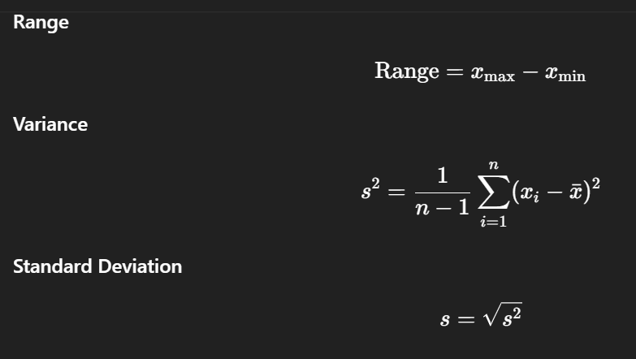

(c) Distribution Shape
Skewness
- Measures asymmetry of distribution
- Positive skew: long right tail
- Negative skew: long left tail
Kurtosis
- Measures tail heaviness and peakedness
- High kurtosis indicates more extreme values

Graphical Descriptive Methods
- Histogram: distribution of a single metric variable
- Boxplot: median, quartiles, outliers
- Bar chart: categorical data
- Scatterplot: relationship between two metric variables
These visuals help detect:
- non-normality
- outliers
- unusual patterns

Role of Descriptive Statistics in Research
Descriptive statistics are used to:
- profile respondents
- summarise survey data
- explore data quality
- prepare data for inferential analysis

“What does this dataset look like?” (Correct)
“Is this effect statistically significant?” (Wrong)

Inferential Statistics

Definition
Inferential statistics use probability theory to:
- make generalisations from a sample to a population
- test hypotheses
- quantify uncertainty
- assess statistical significance
Inference always involves sampling variability.

Population and Sample
- Population: the full set of units of interest
- Sample: a subset drawn from the population
Because populations are rarely fully observed, inference relies on samples to estimate unknown population parameters.

Parameters and Statistics
Inferential methods estimate population parameters using sample statistics.

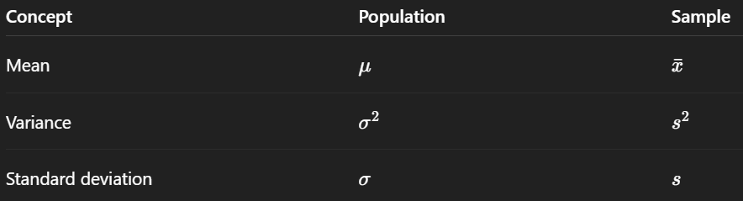

Statistical Inference Framework

Hypothesis Testing
Inferential statistics commonly follow this structure:
- State hypotheses
- Select significance level
- Compute test statistic
- Obtain p-value
- Make decision

(a) Hypotheses
Null hypothesis
H0​: No effect or no difference (H0​: μ equal 50)
Alternative hypothesis
H1​: Effect or difference exists (H1​: μ NOT equal 50)
(b) Significance Level
- Probability of rejecting a true null hypothesis
- Controls Type I error
(c) Decision Rule
- If p-value ≤ α, reject H0
- If p-value > α, fail to reject H0

Common Inferential Techniques
Objective | Technique
Compare means | t-test
Compare multiple means | ANOVA
Test association | Chi-square test
Estimate population mean | Confidence interval
Model relationships | Regression

4.3 Confidence Intervals
A confidence interval provides a range of plausible values for a population parameter.

Assumptions Underlying Inferential Statistics
Most inferential techniques rely on assumptions such as:
- random sampling
- independence of observations
- normality
- homogeneity of variance
Violations affect:
- validity of p-values
- reliability of conclusions
Hence, descriptive analysis must precede inference.

Descriptive vs Inferential Statistics
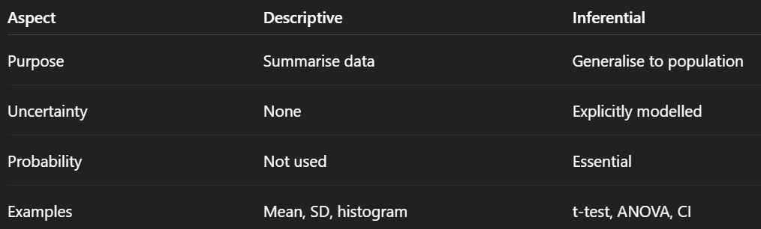

Practical Workflow in AA037004
In applied statistical analysis, the correct sequence is:
- Data cleaning
- Descriptive statistics
- Data visualisation
- Assumption checking
- Inferential analysis
- Interpretation
Skipping descriptive analysis leads to invalid inference.

Summary Table
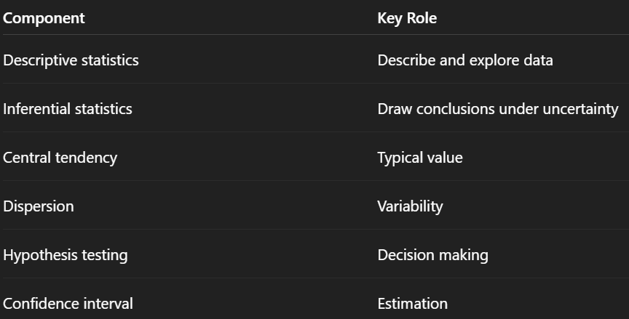

1. Core Distinction
Descriptive statistics
- Summarise and describe observed data only
- No generalisation beyond the dataset
- No probability or hypothesis testing
Inferential statistics
- Use sample data to make conclusions about a population
- Involves probability, uncertainty, and assumptions
- Includes hypothesis testing and confidence intervals
Exam tip:
- If the question asks describe, summarise, or profile → Descriptive
- If it asks test, compare, significant, or generalise → Inferential

2. Descriptive Statistics
2.1 Purpose
- Describe data characteristics
- Detect patterns, outliers, and data issues
- Prepare data for inferential analysis
2.2 Measures of Central Tendency
Mean
- Sensitive to outliers
- Best for symmetric distributions
Median
- Middle value of ordered data
- Robust to outliers
Mode
- Most frequent value
- Suitable for categorical data
2.3 Measures of Dispersion
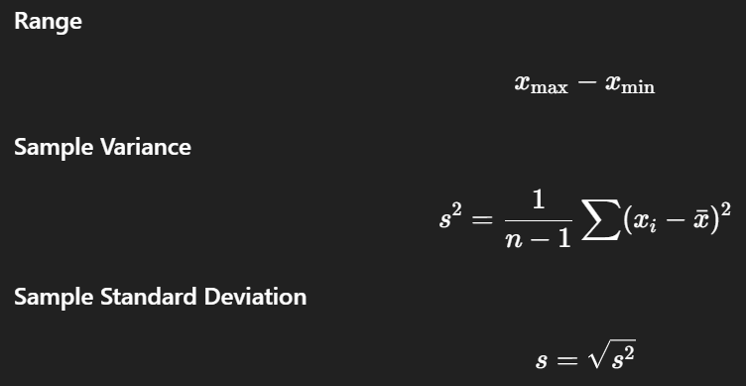

2.4 Distribution Shape
Skewness
- Positive skew → long right tail
- Negative skew → long left tail
Kurtosis
- Measures tail heaviness
- High kurtosis → more extreme values

2.5 Graphical Methods
Graph | Purpose
Histogram | Distribution shape
Boxplot | Median, spread, outliers
Bar chart | Categorical variables
Scatterplot | Relationship between two metric variables

3. Inferential Statistics
3.1 Purpose
- Draw conclusions about a population
- Quantify uncertainty
- Test research hypotheses

3.2 Population vs Sample
Inference is needed because population parameters are unknown.

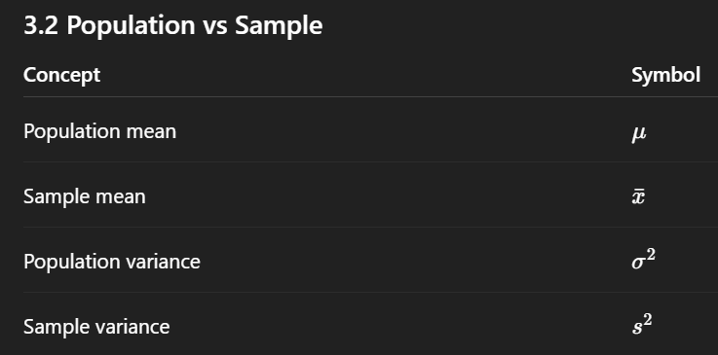

4. Hypothesis Testing
Step 1: State Hypotheses
- Null hypothesis: H0​: No effect or no difference
- Alternative hypothesis: H1​:Effect or difference exists
Step 2: Choose Significance Level (α=0.05)
Step 3: Compute Test Statistic
Depends on test used (t, F, χ², etc.)
Step 4: Decision Rule
- If p ≤ 0.05 → H0​
- If p > 0.05 → Fail to reject H0​
Step 5: Interpretation
Statistical conclusion
Practical meaning in context

5. Confidence Intervals
We are 95 percent confident the population parameter lies within this range. Confidence is about the interval, not the population.
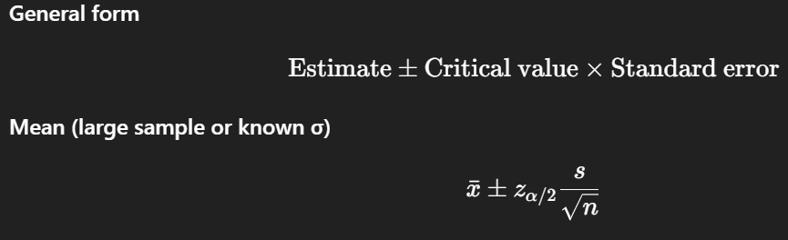

6. Common Inferential Techniques
Objective | Technique
Compare one mean | One-sample t-test
Compare two means | Independent t-test
Compare more than two means | ANOVA
Association between categorical variables | Chi-square test
Relationship between variables | Regression

7. Assumptions (Frequently Tested Conceptually)
Most inferential methods assume:
- Random sampling
- Independence of observations
- Normality (especially for small samples)
- Homogeneity of variance
Exam tip:
Always mention assumption checking when interpreting inferential results.

8. Descriptive vs Inferential Summary Table
Aspect | Descriptive | Inferential
Objective | Describe data | Generalise
Probability | Not used | Essential
Output | Mean, SD, graphs | p-values, CI
Uncertainty | Ignored | Explicit

9. Typical Exam Phrasing
- Descriptive:
“Summarise the data”, “Describe the distribution”, “Report the mean and SD”
- Inferential:
“Test whether”, “Is there a significant difference”, “Draw a conclusion”

10. One-Line Exam Takeaways
- Descriptive statistics organise facts
- Inferential statistics support decisions
- No inference without prior description
- Statistical significance does not imply practical importance

